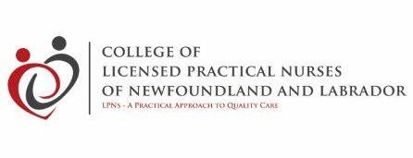

CLPNNL Welcomes New Board Members

ELECTION RESULTS ZONES II and V

The following LPNs have been elected/re-elected by acclamation to serve on the Board of Directors of the College of Licensed Practical Nurses of Newfoundland and Labrador (CLPNNL) for the term January 1, 2020 – December 31, 2022.

Zone II
Charlene Phillips has been appointed for a first term to the Board representing Zone II. Charlene is employed by Eastern Health in Bonavista. She is a member of the CLPNNL CCP Audit Committee.

Zone V
Una Davis has been reappointed to a second term as the LPN Board member representing Zone V.

APPOINTMENT TO A VACANT BOARD POSITION FOR ZONE I:

Zone I
Lori Cooke has been appointed to a vacant position as one of the two Zone I LPN members of the Board, replacing Susan Langin. Lori is employed by Eastern Health in Community Health. The appointment is effective from November 27, 2019 to December 31, 2021.

Congratulations to Lori, Charlene and Una. CLPNNL looks forward to working with them over the coming three years to advance the mission of the College. CLPNNL also thanks Susan for her contribution to the Board this past year.

